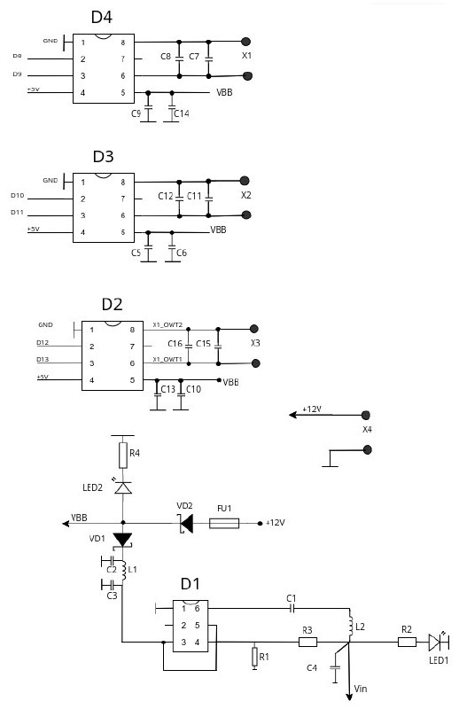

|  |  |  |  |
| --- | --- | --- | --- |
| *Поз. обозначения* | *Наименование* | *Кол.* | *Примечание* |
|  | *Конденсаторы* |  |  |
| *C1* | *X7R 100нФ 50В* | *1* | *C0603* |
| *C2, C5, C9, C13* | *EEEFK1E101SP 100мкФ 25В* | *4* | *SMD, 6.3x5.8mm* |
| *C3* | *X5R 22мкФ 25В* | *1* | *C1210* |
| *C4* | *X5R 47мкФ 16В* | *1* | *C1210* |
| *C6, C10, C41* | *X7R 220нФ 50В* | *3* | *C0603* |
| *C7, C11, C15* | *X7R 10нФ 50В* | *3* | *C0603* |
| *C8, C12, C16* | *X7R 470нФ 16В* | *3* | *C0805* |
|  | *Микросхемы* |  |  |
| *D1* | *TPS561201DDCT* | *1* | *SOT23-6* |
| *D2, D3, D4* | *A4950E* | *3* | *SOIC-8* |
|  | *Предохранитель* |  |  |
| *FU1* | *Littlelfuse 0451010.MRL* | *1* | *CAPMP7343X310N* |
|  | *Дроссели* |  |  |
| *L1* | *SLF7032T-101MR45 100мкГн* | *1* | *SMD, 7x7x3.2mm* |
| *L2* | *MCW-0420-4R7-N1-M 4,7мкГн* | *1* | *0420* |
|  | *Светодиоды* |  |  |
| *LED1* | *LED0603* | *1* | *Green* |
| *LED2* | *LED0603* | *1* | *Red* |
|  | *Резисторы* |  |  |
| *R1* | *R0603 1% 80,6кОм* | *1* |  |
| *R2* | *R0603 1% 1кОм* | *1* |  |
| *R3, R4* | *R0603 1% 10кОм* | *2* |  |
|  | *Диод* |  |  |
| *VD1* | *SS56* | *1* | *DO-214AC* |
| *VD2* | *MBRD20200CT-13* | *1* | *TO-252-2(DPAK)* |